

**Latest Reports from the District 9980**

**Outbound and Inbound students.**

**August 2019**

**Outbound [returning home in January 2020]**

**Vincent Chile **

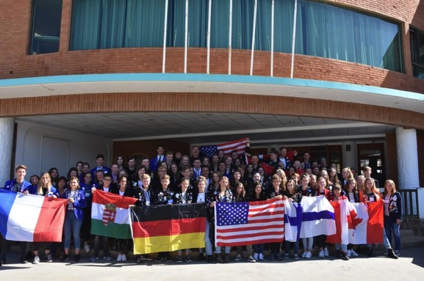02/09/2019

I have not once so far regretted my decision to undertake this exchange since my arrival at the end of January this year. It has been full of highlights and currently is it feeling like I am going through all of the best parts of the last year of high school, without any one the stress from actually having to study to earn high marks during school. I have been busy learning dance choreography and playing sports for my schools house competition. Outside of school, I try to spend as much time as I can spending time with friends or my host family. I also make sure to set some time aside every week to study the grammatical parts of Spanish, as I understand that this is the best opportunity that I have in my life to learn a new language, so I want to try my best to make the most of it.

These past couple of months have been strewn with changes to my exchange. I have changed host families and I am now living in my second and final one. It is exciting to live with a different family that demonstrates a new viewpoint on the Chilean culture.

At the end of last month included the arrival of the new inbound exchange students from various parts of North America and Europe. It was great to receive an invitation to come over and help out the Rotarians with activities and translations. The fact that I am now able to confidently translate my newfound Spanish skills into English or French makes me very happy, as it means that I have taken leaps and bounds in my language learning progress. The orientation weekend was also ridden with strong feelings of déjà vu from when I had arrived and new the giant group of ‘oldies’ (exchange students that had arrived before you). I feel like I have begun to repay the favour that I owed my oldies, because they were so kind and willing to answer any exchange questions as well as invite me to various activities.

I am looking forward to the next following weeks. My school will be performing several Chilean dances as a presentation, my year in particular will be dancing what is known as Cueca, which is the national dance between a man and a woman. And a couple of weeks from now, Chile will be celebrating its independence day, where I have plans to travel to the famous south of Chile, which is known for its natural beauty.

**Leah Denmark **

Kia Ora fra Danemark :)

Two Danish words have become superglued into my vocabulary: “Hvorfor Ikke”. They translate to “Why Not”. I admit that the first few occasions where I said Hvorfor Ikke all involved either flødeboller, lakrids or ice cream, but since then I have had a lot of practice saying these words as my answer to pretty much every opportunity that has come my way. As a result of Hvorfor Ikke, I have reaped many benefits including improved social skills, better Danish and greater awareness of the world around me.

 So what are the quirkiest things I’ve said “Hvorfor ikke” to in the last 2 months?

-volunteered at Sølund, a massive handicap musik festival. Danced with amazing people! (and got free hugs!!!)

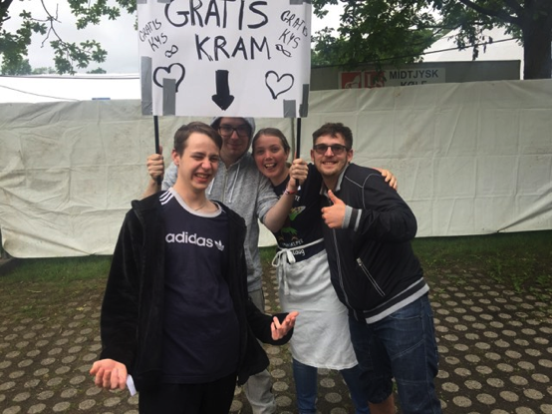

-saw a football match where our home town lost (that was a silent car ride home with my host Dad)

-patted a Royal horse in Copenhagen and saw this wee fella in a park (isn’t the paradise duck native to New Zealand? )

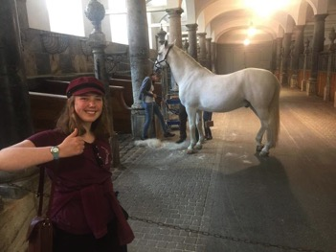

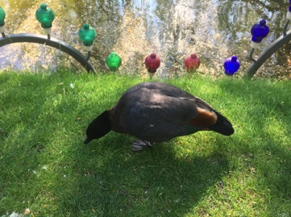

-attended 3d printing labs

-swam across a small lake called Almind Sø

-volunteered at a supermarket staff party, raising funds for the local handball club. Here I got to meet Danish singer KESI. (see below for our attempt of making “NZ” with our hands).

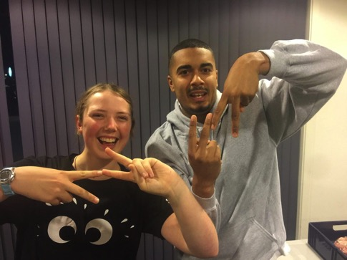

-gave presentations about New Zealand at various Primary and Secondary schools around the area and invented a fun game called “kiwi”

-participated in a outdoor program where I sailed with canoes, made a fork out of a branch (chopsticks would have been easier), caught a fish and ate half a watermelon without using utensils

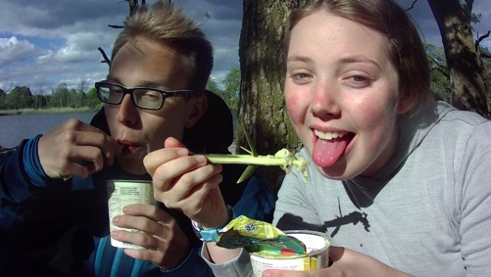

-went on the East and West coast of Jylland on the same weekend (it could honestly be done in a day but I wanted to explore both in more depth)

-ran through a field of rapeseed with friends, despite my mild allergies to pollen (it was worth it).

-kayaked around outer Copenhagen collecting rubbish as part of a new greenification initiative

-sabotaged a Men at Work concert with a New Zealand flag (I waved it especially high for “Down Under”). It was slightly sad because nobody noticed that it wasn’t the Aussie flag (even some of the band members).

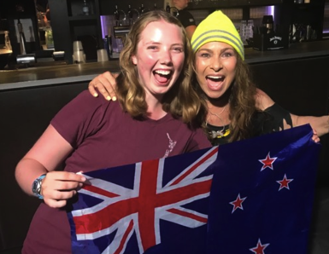

-seen the Tollund Man (a man who was executed circa 2400 years ago and has been preserved by the swamp)

-attended a comedy vocal sharing experience on this house bus. 10/10 fun!!!

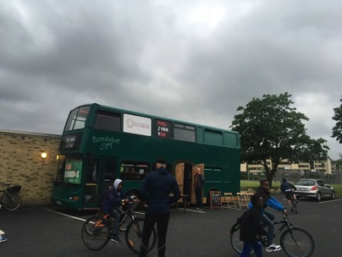

-learned how to dance Les Lanciers, a traditional French dance from the 18th century still common in Danish graduation ceremonies. I turned up in style (see below)

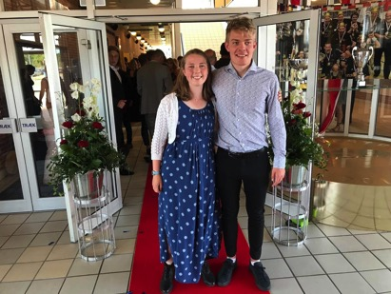

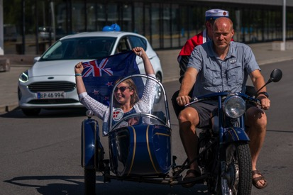

-signed up for a Danish course in Horsens that requires me to take a bus before 6 in the morning for the next two weeks (as a teenager I see this one as a big achievement).

Thank you again Rotary for your support, without you I would be more narrow in both mind and body. I also highly encourage anyone reading this to say “why not” to the next opportunity that comes your way. You have nothing to lose and knowledge to gain. Vi ses!

I am sitting at the train station, eating what any New Zealander would call a Danish. In Denmark it is called a *Wienerbrød* (translating to bread from the Austrian capital of Vienna). Apparently it was invented in Denmark by Austrians, hence the name crossover. This useless knowledge of an amazing breakfast option (sorry Mum) really goes to show how multicultural our world is, once you dig a little deeper.

My exchange year is flying by, just like everyone said it would. But also in steady ascent is my Danish (not the pastry I could have thrown for the sake of a Dad joke, but the language). I naturally encountered a bit of turbulence some weeks back but now I’m happily at cruising altitude.

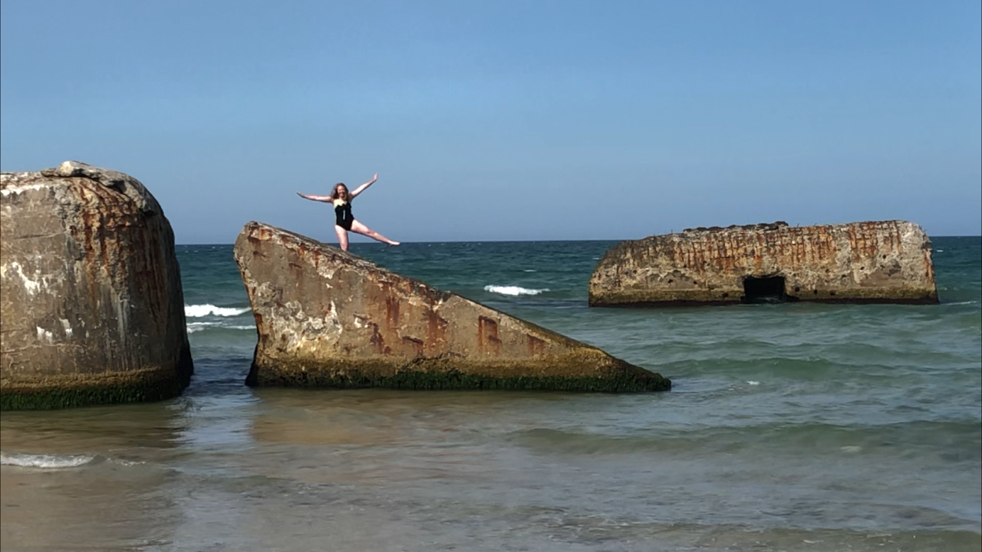

Above: Leah’s failed audition for the Jet Star commercial (WW2 bunkers in Hanstholm)

Going back to school recently, I was relieved to find that I could understand a lot more and additionally had the confidence to ask more questions and present projects in Danish. I also have an exciting new teacher Nicole, she is very engaging and has sparked my interest in Business Law.

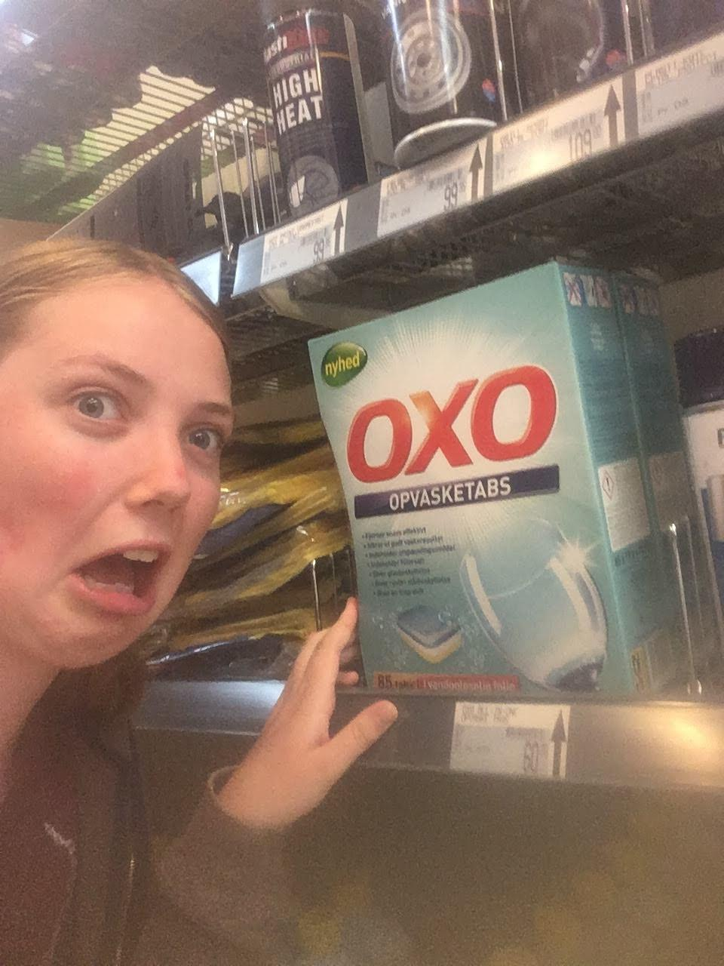

Above: Oxo isn’t stock cubes in Denmark, it’s dishwasher tablets (I’m glad I didn't find this one out the hard way)

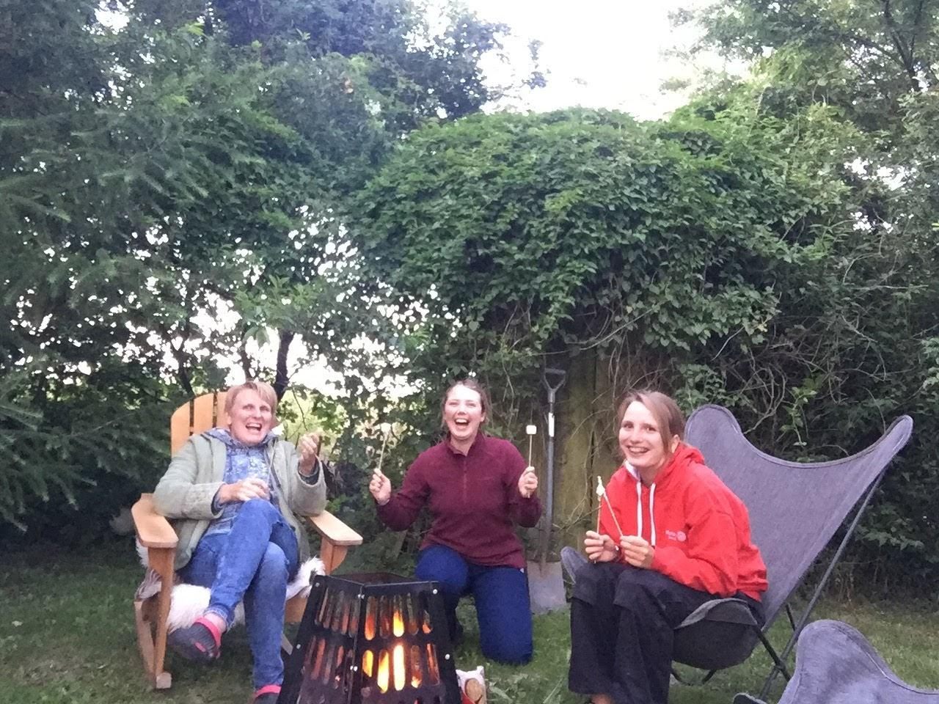

Above: Marshmallows, host family, singing Fred Dagg’s “Gumboots” around the campfire. The perfect recipe for happiness.

Last Weekend I was also fortunate enough to attend Horsens Middle Age Festival. This was one of the first events I found out about when I first Googled Denmark, I am so happy that I went. I attended the festival with a Polish and a Romanian friend. 3 friends became 6 when some strangers wanted to buy my dress up hat (which I had made using good old Kiwi ingenuity and an old t-shirt). We bartered for a price and I agreed on it under the condition that we hang out for the rest of the evening. This story is a good example of sliding doors; a moment later and we would have never crossed paths. It has served as an eye opener to me that one should not fear spontaneity and that fantastic people live all around us.

Tusind tak Rotary for fantastisk muligheten! Thank you Rotary (x1000) for this fantastic opportunity!

**George Austria **

I’m fast approaching the halfway point on my exchange and going through the emotional experience of farewelling my homebound oldies. I’ve made some great friends in the group and I was look forward to meeting the newbies in August.

Over the last few of months it’s been getting much hotter and the weather is now consistently in the low 30s - not the most pleasant heat in a built-up city like Vienna. I did a farewell camping trip with the other exchange students to present the completion certificates to the oldies and formally say goodbye. I got eaten alive by mosquitoes but enjoyed the beautiful village of Mattsee, in Salzburg state.

A highlight of the last two months for me was travelling to Salzburg and staying with a friend’s host family with 5 other exchange students, volunteering a helping hand to build a new deck for the family. We got our hands dirty in sweltering heat and later a thunderstorm but we got the job done and were rewarded with amazing food and hospitality. We got along so well with the family that they invited us back two weeks later to do a free canyoning trip with the host dad, who is a trained canyoning guide. It was so much fun and I gained a lot of confidence by free-falling 14 metres into a narrow canyon with no ropes - had to check some of the fine print on my insurance for that one. Looking forward to the rest of Summer and the second half of my exchange!

I’ve just welcomed a big group of new inbounds to Austria, with around 20 living near me in Vienna. I feel very settled in here and it’s been great to show them around my new home. I had a great summer and managed to see 7 of the 9 states of Austria, with lots of swimming, camping and traditional Austrian festivals.

I spent a lot of the summer building closer relationships with my local friends and meeting lots of new people, so I now have a solid base of friends. It’s a good feeling to walk down the street and bump into people you know in a city of 2 million people! My German is continuing to improve but I want to make an effort during this school semester to learn more complex sentence structures and improve my grammar in order to better engage with the school curriculum.

It’s scary to think I’ve been here nearly 8 months already and my return date doesn’t seem too far off now, but I’m looking forward to making the most of my last 4 months in this beautiful country.

**Sabrina Taiwan **

It’s now been nearly 8 months since I arrived in Taiwan and I cannot believe how fast it has gone by. Truthfully this year has been one of the most difficult of my life, but also one of the most productive and rewarding.

At the start, especially because Taiwan was not one of my choices, I found it so difficult to accept that I was actually living in Taipei, and that I should be learning Chinese. Slowly I started to fall more in love with the city and language, and now can say confidently that if I did this again, I would put Taiwan as my first choice. To me, this chance to be immersed in a Chinese speaking environment and experience life in a city of over 2 million people is so precious.

Recently I have started the new school semester. Over the summer holidays, I opted to do a Chinese language course at a university where I met students from Korea, Vietnam, Japan, and even Russia, as well as went for lots of hikes and to some really dope art galleries.

I am really looking forward to the last 4 months of my exchange, and am also really excited for 2020 and the chance to apply some of the language and life skills I’ve gained over this year.

I met up with Sabrina who has just come back from Dunedin where she had her Exchange year!

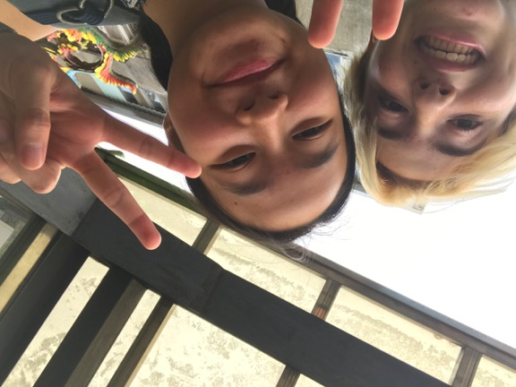

**Reuben Sweden **

Over the summer I have been very busy focusing on Sweden and living my exchange life to the fullest. I am feeling very familiar with my surroundings now and I feel like Sweden is my new home and feels more like home than New Zealand. Time has flown by so quickly and it’s hard to believe that i’m closing in on the end of my exchange soon.

I recently went to Åre on a rotary wilderness camp where we went very far north, went hiking and experienced true Swedish wilderness. On this rotary trip I met the new exchange students in Sweden and made some new friends. Meeting the newbies let me compare my current self to how shy I was and how different it was when I first arrived, feeling a little homesick, not knowing the culture or how anything works, just like how the newbies that I met felt.

The past few weeks over the summer has meant no school for over 2 months and i didn’t feel lonely or bored for any of it. My host family and my friends have kept me busy all summer, going fishing, going on trips throughout sweden and even going to finland on an overnight cruise for a couple days.

Coming on exchange I was warned that I would not return the same person and I would change incredibly, I didn’t believe it at first but now, looking back, I realise how much I have changed as a person and I haven’t even tried.

I’m really looking forward to the last 4 months of my exchange and I kind of don’t want it to end.

**Jasmine Germany** 

My summer holidays were amazing. We went to many different places and

explored many different things.

I attended the Rudolstadt Volksfest, went to the Wine district of Germany and also went to North Italy for 12 days. In Italy I tried many different foods as well as going on very long walks every second day.

I am so surprised by how fast this year is going and I really don't want to go back home.

This past week was very hectic. The biggest festival of its kind in Germany was held in the small city of Mühlhausen (which is where I am staying). KIRMES. Kirmes is a week long celebration that involves partying and drinking every night for a week. I didn’t go out every night but I did have a lot of fun when I did go. There were many students hungover during school which was quite funny and seeing the teachers some nights. We even got to skip German on Monday

because our teacher wanted to go to ‘Kirmes Montag’. I have been struggling

with home sickness recently but talking to my host family has helped a lot.

**Ella Belgium** 

SOS where is the time going? I acknowledge that the majority of my posts and reflections on my exchange so far have started with remarking how fast it has passed, but this is something that I think of consistently.

Keeping constantly busy has definitely accelerated the time. These last two months have been almost overwhelming, with very few days where I don’t have an activity planned. And now that the summer holidays have started, I’m expecting even more.

Last couple of months have included visits to Strasbourg and Amsterdam, excursions with my host family and many exchange student outings.

At the beginning of May, my school had a three day trip to Amsterdam. A huge cultural difference I have found here already is how easy it is to travel between countries. To only have a five hour bus ride to the Netherlands amazing. Our first day, we arrived in The Hague in the early afternoon where we got a tour of the area. The area was beautiful but I found it seemed to be exclusively tourists in the city. On the other hand, Amsterdam was vibrant and everything I had imagined. My whole year group was on this trip so I had all my friends with me which was great for getting to know them better. Biking around an island definitely helped with that, which is what we did the second day. Even though the season had just ended, there were still fields of tulips still hanging in there. Another major highlight of this trip was the boat trip through the canals where I got to see the mix of old colourful buildings and new modern structures. Got to take some cute photos too of course.

As if I haven’t travelled enough, I got another three day trip to the region of Alsace, France, with my close friend Linnea from Canada and her host parents. We toured the region which was filled with cute little towns, vineyards and lots of history. Notably, we visited a concentration camp. This was a sobering experience. As someone who has lived far away from where these events occurred, I have always had a sort of filter over this reality. Seeing the conditions and reading about the experiences of the prisoners put into perspective what happened. I am grateful to have been able to take in this past and learn for the future.

For more of a culture side of Belgium, my host mother and sister took me to see the Ommegang, a reenactment of when King Charles presented his son Phillip II. Over 1400 performers in costumes from the middle ages demonstrated all sorts, from stilt battles to a flag performance. This also took place in the Grand Place, creating an incredible show which really showed the history of Belgium.

While many, many things have passed on my exchange, I can only write so much. Over this summer, I am looking forward to lots of traveling and sun. Forever grateful for what I have and all the people who’ve made this possible. Until the next update!

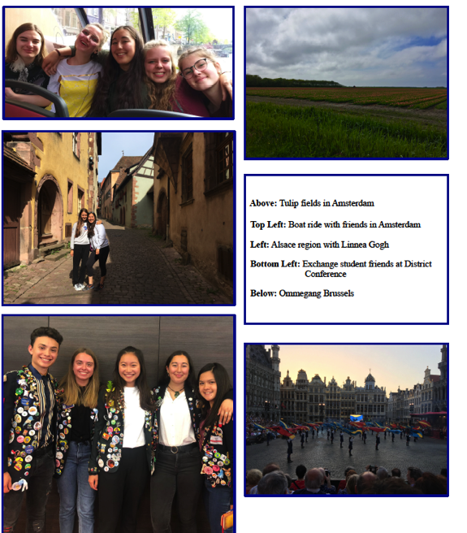

Doing an exchange in the Northern hemisphere means that I get to profit from two months of summer holidays. And man have I tried to make the most of it.

Since school let out, I have visited Spain, France, the Netherlands and of course, much of

Belgium. I have been incredibly lucky to end up in amazingly generous host families, as seen with my first one who took me skiing. My second family took me with them for 10 days in Spain, spending time in the Andalousie region. Never have I seen such stunning architecture or eaten so well. Since the heat was certainly a little overwhelming at times (almost always above35º) , we spent lots of time lounging by the pool and getting that summer tan. During the evenings, we visited so many different towns.

Much like my own family in New Zealand, my second family liked to really see the cultural side of the area. From castles to cathedrals, we didn’t miss a thing. A highlight for me was definitely the Place d’Espagne in Seville; I’ll let the photos speak for themselves.

Shortly after this visit, my mother Annabelle came over for a two week visit. The emotions which came with this are some of the most confusing I’ve ever felt. A good friend of mine rightfully explained that when people from your home country mix with your host country, it’s like a cross over episode of a TV show. It was so cool to show my mother everything that I had lived the past 6 months. We also took advantage of the time to go visit friends and family throughout France. Once again, a heatwave followed us from Paris to Lyon and down to Marseille. Can’t complain however because we managed to do so much exploring and eating. Emphasis on the eating….

To top off the best holidays of my life, my third family has taken me both to the Netherlands and a weekend visit in Belgium. To go from New Zealand to Zeland was very funky, but I understand why we have the name we do. While the Netherlands lacks the mountains in the distance, the environment is otherwise very similar. Another exchange student came along with us, and once there, we met up with two other families. My third host father goes diving, so while they were out in the cold water, we went visiting the beaches and towns. A really chill week overall.

Yesterday, my host parents took me to visit Bruges, which I would honestly say is the most beautiful city I’ve seen yet. Unsurprisingly, it is very similar to Amsterdam and Ghent although there is a further charm in the fact that it seems cosier. I really enjoyed my time spent alone with my host parents, getting to spend time together seeing new sights.

I am forever grateful to everyone who has offered me the opportunities I’ve been lucky enough to receive. As always, I look forward to the rest of my exchange!

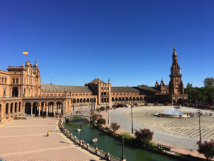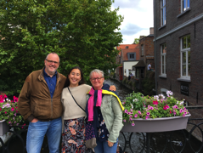

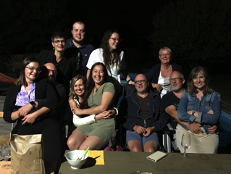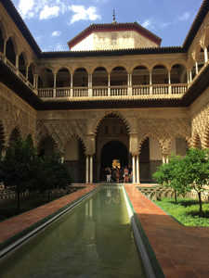

rotaryyouthexchange rotaryyouthexchange rotaryyouthexchange rotaryyouthexchange

**Inbound [Arrived in D9980 in July 2019]**

**Irina Switzerland Taieri **

I am now in New Zealand for 5 weeks. It is crazy how time flies. In the first week I didn’t do much, because my jetlag was pretty bad. In the second week I did some fun activities and started to explore Dunedin together with my host family. They showed me the St. Clair Beach and Dunedin’s main street and we went ice skating and bowling.

In the third week I had a trip coming up with my Sports & Recreation class to Invercargill. We went caving and did High Ropes. As soon as I arrived at home, I had to pack my stuff again to go skiing in Wanaka with a lovely family from my Rotary Club. I really enjoyed the skiing trip and it felt like being in the Swiss mountains.

The 24th and 25th of August I had a Rotary Orientation weekend. We went to Tunnel Beach, which was stunning. And I got to meet the other In- and Outbounds. It was nice to meet some people, who are in the same situation as I am, and learn about their home countries. It was lots of fun and I am looking forward to the South Island Tour.

Last week was exams week and I had school off because I don’t have to do the exams. So I used my free time to catch up with school at home.

I already met so many nice people and got to do and see a lot of things. I’m very happy to be here and thankful that I got to do this exchange year with Rotary.

**Hanna Sweden Queenstown **

I arrived at Queenstown airport. My hostfamilys, some rotary members, the rotary president, Ross Beal and his wife Roxanne, and my conselour Darren Rewi, gave me a warm welcome. They stood in the arrival hall with a beautiful sign, and I felt very welcome from the start.

I spent the first two weeks at Tracy and Steve Mcleans house in Lakeside Estate, about a ten minutes car drive to central Queenstown. They had host 8 students before me so they where very experiences witch felt good. They are two active persons and brought me on many activities like night luging, family parties, dinners, a hike, movies etc. I had a fun time with them and they made me feel welcome in their home.

I was free from school the first ten days, and my other host-mother, Lee-Ann Lines, brought me on many adventures. We did a roadtrip to Glenorchy, visit a bird conservation park where we saw kiwibirds, she took me to Wanaka, and also we visited another rotary exchange student from Chile called Eugenio in Cromwell. She is truly a super kind and warm person and I’m very glad I have her.

I had a bit of a bad start at school. Tthe international students were just going to stay for 2-3 months so I had to get new kiwi friends. Most teachers did not introduced me to the class witch they always do with a new student back home. But after the first week, I made new friends, and now it feels much better. Altought I feel like I’m more quiet than home because of the language barrier. But after talking to the other exchange students on the camp we would relate much, which feels good.

I don’t need to do the exams in school so it’s not that much pressure, even if I have to do much school work. It’s easy exept for my French class with is a bit hard, but I want it like that. Because I learn more in that environment.

I moved to my second host family who lives in another community called: Shotover Country. I live here with my host-mother Annabelle, my host-father Gen and my host-brother Miles. And they have many animals. Actually they feels a bit like my Swedish family at home. They are very kind and it feels good. We do fun things and they give me a lot of freedom.

It’s very fun because my dream job is to become a diplomat/work at an ambassed and it turned out that Annabelle’s father was an American diplomat so she have told me a lot about the lifestyle and later near Christmas I’m going to meet her brother who works with those kinds of things. It’s very interesting!

I have held my speech for Queenstown Rotary club. It was about 20 minutes long and was about my home country: Sweden, my family and myself. I got many questions and it felt good that people was so interested.

We had a dinner with all my host parents, my counsellor Darren Rewi and his wife Debbie Rewi, and the Rotary president Ross Beal and his wife Roxanne Beal. It was a lovely night and they surprised me with a ceremony where Darren blessed a pounamu stone that all of them together had bought to me. I felt so thankful and happy.

I truly think it’s so exiting to meet so many people from all part’s of the world. My dream have always been to see the world and I hope I’m gonna go and visit all new friends i made during this year in their home countries. **I am very happy and thankful to be here: What an adventure!! And it has only begun…**

**Lilly Austria Invercargill North **

Hi everyone, I am now 2 months in Invercargill and the weather is getting better. Still raining every 3rd day but that’s better than every day.

August started well with an invitation to my Rotary club president Sharon Hamilton. She invited me and two other exchange students, from Sweden and Denmark, to stay at her beautiful house for one weekend. We had a lot of fun going into her spa, watching the rugby of our boys school team and go shopping of course. At that weekend it snowed it really felt like Christmas. But the funny thing was that everyone was freaking out because of 4cm snow. Busses didn’t drive and people were staying at home because it was too dangerous to go out.

Ein Bild, das Himmel, draußen, Person, Boden enthält.
Ein Bild, das Essen, drinnen, Wand, Küche enthält.

Ein Bild, das Wasser, draußen, Strand, Himmel enthält.
Ein Bild, das Tisch, Essen, Person, drinnen enthält.

On the 14th of August I had to get up at 5.30 a.m., because I was off to a trip with Outdoor Education to go Snow caving. With our school van 8 girls (5 exchange students and 3 Kiwis) and 2 teachers where off to Cardrona valley in Wanaka. After a 3-hour drive, we finally reached the snow farm. Where we put on our gear and got an introduction for cross country skiing. After that we took our backpacks and cross country skied 6.5km to a little hut. The way to the hut was exhausting because it was just uphill, but we had a lot of fun talking about our home countries etc.

When we arrived, we started building our snow caves for the night. We made a big mountain of snow and then started digging holes in it. We had 3 floors, but it wasn’t big. Later we drank some tea and had our astronaut food because we were frozen from all the snowball fights. Our teachers asked us if we want to sleep in the snow cave or the warm hut with water a toilet… Of course, I decided to sleep in the snow cave with Wilma from Sweden, Oceane from France and Emily from Vietnam. Ocean and Emily left very quickly. But Wilma and I wanted to get an excellence, so we stayed from 8p.m. to 8a.m. I didn’t sleep the whole night, but I was very proud of me that I did it. After that freezing night we had to ski 8km back. I was not that fast as I was on the 1st day. I think I just had no energy at all.

Ein Bild, das draußen, Himmel, Berg, Gras enthält.
Ein Bild, das Himmel, draußen, Straße, Boden enthält.

At the end of August I had my first meeting with the other Inbound students. We met in Mosgiel. I really like my travel group and I am looking forward to all the things I am going to do with these people. We also met the Outbound students 2020 from district 9980. It was so interesting to see that the questions from parents and students were so different as my questions were. They asked way more about school. I didn’t even think about school in New Zealand. But we really had a good time talking about the same thoughts and answer some questions about my first month of my exchange year. We also went to Tunnel Beach what was just stunning. Overall I can say it was a successful weekend and it gave me some thoughts about that year.

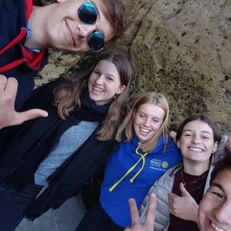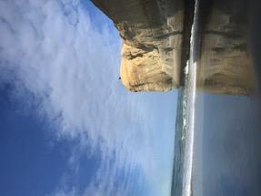

Throughout I am feeling very well here except I must do the exams which is not that easy like my teachers think, but I have a great time here and no problems.

**Eugenio Chile Cromwell **

My days in New Zealand begin to be a countdown, I'm going to change to my last host family and summer is approaching, which is a sign that it's time to return home.

During the 7 months here I have lived very nice experiences, met very nice and generous people, I had to do things that I had never done before and many times not very funny things, but the most important thing is never to give a "no" for an answer . On the other hand, it is impressive and very comforting when the people around you tell me that my English has improved a lot, I know it is not perfect English, but it allows me to communicate and understand more easily. Recently I was sharing with the new exchange students, on the one hand I felt old since I knew everything that would happen. On the other hand it is nice to see a group full of dreams and desires to fulfill in this experience.

For my part lately I have not done many new things ... I go to the snow every Thursday with the school and usually on weekends with my family or with friends from the school, with my family we make movie nights and make a ranking of The baddest movies. It is not necessary to do great things to be happy.

**Calix France Waimate **

I have been here in New Zealand for 2 months now and everything is going wonderfully well

I was welcomed by my Counsellor, Adam and his family with whom I spent my first week.

This week was wonderful and very interesting for me, I was able to discover many things like food, lifestyle... also I didn't speak the language very well before leaving especially since the particular accent of the kiwis and their speed didn't help me but I like challenges. During this week Adam helped me get some necessary things for my years like a bank account, a doctor or even gumboots, 100% kiwi boots essential for me who will live on 3 different farms during the year.

My counselor's family took very good care of me and took me to visit the surroundings. We also watched some of the Lord of the Rings films that immerse me in these beautiful settings of my new country.

It has been two months now that I have been with my first host family. Thanks to this family I have had two wonderful months so far. Michael takes good care of me and I do a lot of things. I am never bored because there are always things to do on Michael's dairy farm and I am delighted.

One of the main reasons I chose New Zealand was the environment and the landscapes I have heard so much about and indeed there Its full of beautiful landscapes here. I had the opportunity to go to many beautiful places like the Moeraki Boulders, the Oamaru penguins, Caroline bay and many more with Michael. I also went to Mount Cook with Rotarians where we participated in a rare bird release in nature.

I also joined the Waimate scout group where we meet every Wednesday night. We also do some outings like at Lake Tekapo where we went ice skating, hot pools and we also dived into the cold lake. Not long ago we went bowling. I have a great time with this group.

I am attending Waimate High School and I feel good there. Despite having finished high school in France, the school has arranged a schedule according to my preferences, So I chose subjects that I like well as a biology sport or agriculture in connection with my future engineering studies. I also participate in an outdoor activity course where we have already gone skiing at Mount Dobson and we are preparing a mountain bike trip to Queenstown. And finally I joined a Maori singing group where I have the chance to learn many things like the haka and other songs, we will hold a competition in September.

I was able to meet the other exchange students and leaders of my district during the integration weekend in Mosgiel.

To conclude I spend very good moments in New Zealand I never get bored and have the chance to be surrounded by lovely people and to have a rotary club so present for me. I am also always amazed by the surrounding landscapes.

**Wyn Germany Wanaka** 

My first two months in Wanaka have been really enjoyable. Mt. Aspiring College and its students have accepted me nicely and I am already a part of it. I feel like the Rotary Club of Wanaka has already included me as one of its members and I regularly attend the meetings. They offer me lots of opportunities for activities and I’m happy that I’ve seen some things that way. I was even able to borrow a bike and a snowboard through my club which is great.

A great thing about MAC is its international department, offering to meet other international students besides Rotarian exchange students. And the activities offered by its outdoor facilities are simply amazing: for me that was cross country skiing, snowboarding, rock climbing and even staying in a mountain hut overnight, which was a great experience. Classes are slightly different but nevertheless interesting. It is admirable to see how advanced New Zealand is in its use of digital technology compared to Germany.

Just as being able to ski and do lots in the outside, I am happy to be able to improve my English, both written and colloquial. My “ESOL” (English as a second language) teacher wants me not only to participate in regular English classes, which is quite rare, but also to sit the Cambridge exams next year. She also wants us to hand in a “diary” every week and tests us on new vocabulary. I’m thankful for this opportunity and will make the best of it.

I am very much looking forward to going to Wellington with my host family and then join the school’s hockey team in Blenheim for an interschool tournament. Integrating through sports and hobbies I find is easiest for me.

One of my personal highlights this term was the In-/Outbound weekend in Dunedin where I got to meet the other Inbounds and future Outbounds. It’s nice to meet the people I am going to do a lot of stuff with and make friends with them already. I think the trips are going to be enjoyable in this group of people. And I had a little private tour through Dunedin as well (thanks Alan).

Another awesome thing was visiting places like the blue pools and Glendhu Bay here at Lake Wanaka with my host mom and to watch two games of rugby with my counsellor. Everybody is trying to make my stay interesting, which I truly appreciate.